DS Design Document v1.0

Author: Simon Barratt

**Football Director is the property of Sports Director Limited.**

TODO

* Add EFIGS support, add language select back in (from previous revision)
* Check interface for any possible issues with EFIGS
* Integrate other minor feedback from meeting notes w/ pinnacle
  + Music only on main menu
  + Jingles throughout game upon certain events (needs defining)
  + Line graphs showing team form / progress (based on code tests)
  + Live league table during match
* **Go through and make comments in other colours**

Will help towards establishing TODO list and clarifying any points

* Work out dates for when we can accept changes to art (pre-Beta)
* Look at other management games for ideas for news / commentary
* Compare player function

#### Contact Details

For further information on this document or Four Door Lemon Ltd, please contact:

Simon Barratt

[simon@fourdoorlemon.com](mailto:simon@fourdoorlemon.com)

+44 (0)870 1241215

#### Version History

|  |  |  |  |
| --- | --- | --- | --- |
| **Version** | **Changes** | **By** | **Date** |
| **0.1** | Initial version | Simon Barratt | 04/10/07 |
| **0.2** | First draft complete, some screens to expand upon still and a few bits to drag in from meeting notes also | Simon Barratt | 20/11/07 |
| **0.3** | Second draft | Simon Barratt | 22/11/07 |
| **0.4** | Final draft | Simon Barratt | 27/11/07 |
| **1.0** | Official DDP version | Simon Barratt | 28/11/07 |
| **1.1** | Updated with changes discussed with Pinnacle (EFIGS etc) and added queries / comments on various parts | Simon Barratt | 03/01/08 |
|  |  |  |  |

#### Understanding

* Mock-ups are purely illustrative and may not correspond to the exact look of any of the final screens.
* Some of the features and screens may change slightly from their descriptions here due to the iterative process of development.
* Some screens aren’t mocked up in this document as they are either very similar to existing screens which have been mocked up or are very simple in their design and will be made and tested as part of the development process.
* During the development process any improvements that are made to the game interface may not relate to the designs in this document.

#### Table of Contents

Game Overview 5

Overview 5

Feature summary 5

Nintendo DS details 5

Languages 5

Menu System (DS) 6

Flow Diagram 6

System Setup & Logos 7

Start Screen 7

Main Menu 8

Creating a New Game 9

Options Menu 10

Screen layout 11

General Notes on Screen design / Animation 13

Control list 13

Screens 14

News / Status screen 14

Screens by menu 15

Club menu 15

Squad (and formation / roles screen) 15

Training 17

Wages and contracts 18

Club fixtures 18

Tactics 19

League menu 21

League fixtures 21

Cup Fixtures 21

League and Current Form Tables 22

Leading Goal scorers/Disciplinary Tables 22

Cup Schedules 23

Admin menu 24

Bank, Accounts 24

Job Centre Screen 24

Youth Squad 25

(No mock-up, similar to Job Centre) 25

Transfer List 25

General screens 27

Match Intro 27

Match screen 27

Progress 29

Incoming Transfer Offers 29

Employee negotiations 31

General (spawned from clicking on an item or from a selection) 32

Match Report 32

Player Transfer Status 33

Youth Profile 33

Employee Profile 34

Player Profile 34

Manager Profile 35

Player requests transfer 35

Player Contract Negotiations 35

Player Loan Negotiations 36

Club Transfer Negotiations 36

Sack Player 37

Monthly Awards 37

Team of the week 38

Control System 39

Help System 39

Music and SFX 39

Milestones 40

# Game Overview

## Overview

**Football Director** is a football management game aimed at casual gamers new to management games, it achieves this through an easy to use interface and through providing default settings for the more specific areas of the game which will let a player just focus on matches. At a deeper level it provides tactical and strategic depth that an experienced management gamer can appreciate and they can become involved in the statistics and training of their players and of players they wish to find in the transfer market. This document describes the development and design of the version for the Nintendo DS games console.

## Feature summary

* Addictive strategic and tactical play
* Control any English league club
* Access players and teams from 4 other leagues (Spanish, Italian, German, Scottish)
* Watch your matches unfold with exciting commentary and hear the crowd respond to your team’s performance.
* Spot upcoming youth team players and train them to their full potential.
* Manage and negotiate player and employee wages to control the clubs wage structure.
* Look at league tables based on various criteria to judge the strength of your opposition
* Search the transfer market with advanced filtering options and make crucial purchases for your club.
* Control the training of the squad and focus them on specific formations or set pieces to allow your team to play out your tactics to your desire.
* Control the finances and borrowing of the club to allow investment in new players and employees.
* Easy to use, slick layout
* Great background music to listen to as you play

## Nintendo DS details

* ROM size = 256Mbit
  + Initially budgeted as
    - (for 32MB)
      * 1MB – Executable
      * 14MB – Art
      * 13MB – Audio / Music
      * 4MB - Data
* EEPROM size = 4MBit (512kbytes)

## Languages

The game will be in English only.

# Menu System (DS)

## Flow Diagram

Sports Director

Movie / Logo

Pinnacle

Movie / Logo

Four Door Lemon

Movie / Logo

Menus system data loading

**Start screen**

“Touch to start”

**Options**

Music Volume

SFX Volume

Credits

**Game Menu**

Continue Game

Create New Game

Options

**News / Status Screen**

Main menu exposed on this screen as well as others provides all the access to the game

**Create New Game**

Enter manager name

**Create New Game**

Select team

**In-game options**

Save

Music Volume

SFX Volume

Credits

Back to main menu

Continue game

**All other game screens**

## 

## System Setup & Logos

The first thing that the game will do is set the language to the system setting of the Nintendo DS. Until Language selection screen is completed it will be assumed that the default system language is valid.

Following the above initial check the game will proceed to the logo sequence. The logos will start with the licensor’s logo (Sports Director), followed by the publisher’s logo (Pinnacle) and finally the developer’s logo (Four Door Lemon). It is assumed that the logos will either be full screen static images or full screen movies; these will be shown in the top screen of the DS the bottom screen will display copyright information. The user will be able to skip the logo sequence by pressing the START button at any time.

## Start Screen

Following the splash screen logos the game will display a start screen. This will consist of the games title screen (top screen) and will have the text “TOUCH TO START” flashing in the bottom screen.

#### Mock-up

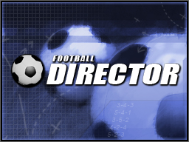

## ToBeDesigned

## ***Main Menu***

After the player has pressed the bottom screen to start the game the player will be presented with the main menu. The menu options will be displayed in the bottom touch screen window. The player will be able to select the required menu item by using the ***stylus.***

The options are as follows

* **'Continue game’** (greyed out if no game is currently saved)
  + **This option loads the saved game and takes the player directly to the main status and news screen within the game.**
* **'Create New Game'** (will ask confirmation that they want to lose their progress)
  + **This option takes the player to the create new game screen described in the section below**
* **'Options'** - enter options menu, also accessible from within game menus
  + Has options for sound / music volume / defaults such as skipping in-game etc.
  + **This sub-menu is described in a section below.**

#### Mock-up



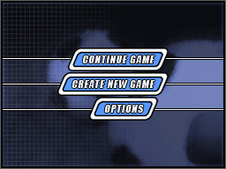

# Creating a New Game

**NOTE: No mock-ups of these screens**

Upon selecting ‘Create New Game’ from the main menu the player is first asked to input the name they wish to be known as in the game. This is done via an onscreen keyboard which is controlled with the stylus, once complete the player presses DONE to move on.

The player is then presented with two list boxes on the bottom screen to select a division and club, the currently highlighted clubs details will be shown on the top and some of the bottom screen and when happy with their selection the player presses DONE to create the game.

There may be a screen similar to the progress screen while the processing work is done on creating the game and saving the game data to the EEPROM.

When the game creation is complete the game switches to the news / status screen which is the default home screen for the player.

# Options Menu

This menu is accessible by pressing the ‘Options’ button on the main menu. This menu contains the game settings.

|  |  |
| --- | --- |
| **Options** | **Details** |
| **Music Volume** | Changes the background music volume throughout the game |
| **SFX Volume** | Changes the sound effects volume throughout the game |
| **Credits** | Game credits |

**Mock-up**





# Screen layout

The Football Director interface consists of various screens which allow you to control your club and players, there are several common elements of these screens which are described in this section.

Note that some of these common elements aren’t present during the match day screens when watching an actual match being played.

## Top Screen Mock-up

The top screen contains several consistent elements, in the top left the current game date and time. At the bottom of the screen is a news ticker displaying information on important matches and a selection of major news relating to your club or country. Along the bar in the top right is the title of the information being displayed in the centre of the top screen.

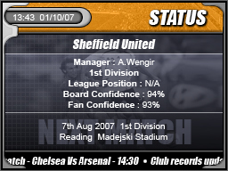

## Bottom Screen Menu Mock-up

One of the main common elements of the bottom screen is the menu system. The four circular buttons on the left represent the various game sections **'Club'**, **'Competition' (NOTE: Changed from 'League')**, **'Admin'** and **'Game'.** Touching any of these buttons with the stylus causes the menu to expand out over the current screen and for the screen to fade slightly. Holding down the stylus and dragging the stylus across the options will highlight them and display at the bottom of the screen a description of the currently highlighted item.

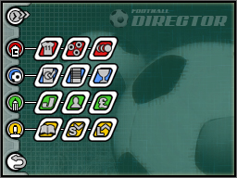

## Bottom Screen Mock-up

As well as the menu along the left of the screen there are two other common buttons on the bottom screen and a title of the current screen contents similar to the one in the top right on the top screen. NOTE: The title on the bottom screen is likely to be removed to provide more space on the bottom screen

The top left button forwards through time until the next match or next important day with activity on it, when going through time the game processes any matches or other events that require action.

The button in the bottom left is a back button which can be used instead of the 'B' button to move backwards through a series of screens. Logic is to be implemented in the back button logic to handle the back history in the case of a decision being made on a previous screen so that the back button doesn’t act as an easy way for a player to get out of a situation via cheating.

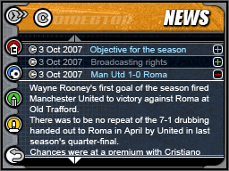

## General Notes on Screen design / Animation

* Screen titles are colour themed the same as menu colours to indicate section you are in.
* The background images will switch every so often randomly between a large set of images to provide variation. The background fade / switch / transition won’t occur while another transition is taking place
* Title bar texture may animate, selectable icons will highlight on ‘hover’ (touch)

## Control list

This is a list of the different ‘control’ types used in the game interface.

* Table (league tables, form tables)
  + Also tables without any lines (for layouts of data)
  + Tables should be scrollable
* Scroll bars (arrow bars go above + below the scrollable items)
* Scroll boxes (left + right arrows either side with text in the middle)
* Buttons
* Tick boxes
* Slider bar for setting values
* Dialog boxes
* Expandable text boxes (like news items)

# Screens

Once a game has been created the player is taken to the central screen for the game which is the News/Status screen. From all screens in the game (apart from when playing a match) the player can switch to another screen using the menu along the left of the bottom screen.

The screens are described below; some of these screens are only reached via other screens and are not directly accessible from the menu.

## News / Status screen

*Spawns: Bottom screen will have hyperlinks in news items for players, teams, match reports, cups (will show fixtures), leagues (will show fixtures) and managers.*

This screen is the default screen the player is taken to at the start of a game and after time has been advanced. The bottom screen shows the news which covers what is happening both in your club and in your countries leagues. The status screen on the top screen shows you information regarding how your club is doing from a higher level including how confident both your board and your fans are as well as when your next match takes place.

*Note status + news titles bars to be combined at top, Club/Country select button to be added to the news screen on bottom.*





The news items on the bottom screen are blue if they are unread and grey if they have been read. The arrows above and below the news items allow the player to scroll between the current and past 7 days of news items. The news items can be expanded to be read with the + arrow by the side of the item.

# Screens by menu

## Club menu

### Squad (and formation / roles screen)

*Spawns: Separate player info screens, transfer status, contract negotiation, sack player.*

The Squad screen is where you can see all of your players at once. The squad list shows three different types of information about your players

* **Skill:** You can see the details for each player including their Handling, Passing and Shooting statistics.
* **Status:** You can see if players are injured or have been suspended.
* **Finance:** See how much they are currently being paid per week and when their contract expires

The list can be sorted by any of these values as well as the default sorted by player position.

This is also the screen where you will decide who the starting 11 will be and allows you to take action on any of your players.

* **Moving players:** If you want to move a player from the starting lineup (11 players and the substitutes) to the squad, simply drag him over the player you want to replace him with and they will swap positions. You might need to do this if a player gets injured or suspended and needs to be replaced.
* **Transfer Status / Sack / Contract negotiation with a player:** Select a player with the stylus and you will be able to view their details on the top screen and using buttons which appear on the bottom change their transfer status, sack them or offer them a contract.

On the right hand side of the bottom screen are two tabs which can be selected to set the teams formation and set the roles of key players in the squad.

With the formations tab you can assign certain formations to your team. This will be the formation that they use for the upcoming match. The user can either drag players from the squad list into the position they want them to play in or drag the existing players shown on the formation around to switch. When the player is dragged from the squad list their name is shown under the stylus. The formation can also be changed using the preset list at the bottom, in brackets the teams rating in that formation is shown (which can be improved through specific training in that formation).

Using the roles tab the corner taker, penalty taker, free kick taker and captain are set by dragging the players from the squad list onto the corresponding red dot on the pitch.

*(Note the mock-up doesn't show all stats which will be listed, the title bar will also be removed from the bottom screen and combined with the top screens bar.*

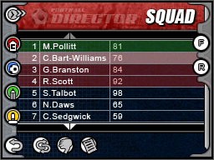

Squad screen with the formation tab expanded

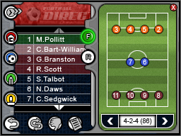

Squad screen with the roles tab expanded

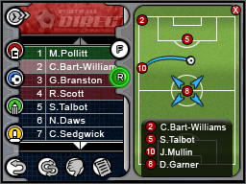

Summary of the selected players’ information shown on top screen

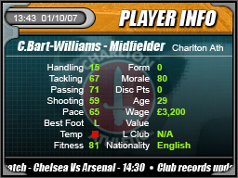

### Club Records

*Spawns: Information hyperlinks from content on bottom screen (players, other clubs, employees, managers)*

Club historical information and records are displayed here; the screen initially starts of showing the managers club however other clubs information can be viewed by simply selecting the desired club from the selection box.

The information is shown across the top and bottom screen with a selection box at the bottom of the bottom screen with a list of clubs with default as own club

The information shown includes

* ***Info:*** *Club info including when it was founded, the manager, stadium name, stadium capacity, average attendance*
* ***Players:*** *Largest transfer fees in / out, appearances, total goals, goals in a season.*
* ***Matches:*** *Record victory/defeat, highest and lowest attendance*
* ***Competition:*** *Shows the highs and lows of league points and position. Highest round reached in any of the cups*

### Training

*Spawns: No linked screens*

This is where the user devises training plans to get the best out of his players and ensure they are at the peak of their performance. It is important that you train your team in-between matches.

Players train automatically each day and unless you change the settings on the training screen they will use the default settings. They will always perform the training; it is only the training done each day that is affected by this screen.

On the right of the top screen is the list of ratings of the squad at various set pieces and skills, on the left is the rating of the squad at playing in various formations.

On the bottom screen are bars to control the focus the training on certain formations, set pieces and types of training. The four bars will add up to 100%, adjusting one bar will adjust the other three bars so they add up to 100%. A bar can be locked to prevent it from being affected by adjustments to another bar (only 2 bars are lockable at once so that moving a bar always has an effect).

Top/Bottom screens



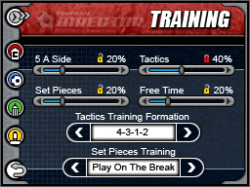

### Wages and contracts

(this screen not mocked up)

*Spawns: Links to employees, players, youth players screens as well as sack, transfer status and youth, senior and employee contract negotiation screens.*

This screen displays a list of all employees, the first team and youth squads, their annual salaries and contract expiry dates. The information currently viewed is set depending on which tab at the bottom of the screen is selected. Selecting a player, youth or employee will display his information on the top screen which show action buttons on the bottom screen allowing the user to renegotiate that person’s contract, adjust their transfer status or view their profile in further depth before making a decision.

### Club fixtures

(partially mocked up using cup fixtures mock-up)

*Spawns: Links to opposition clubs and match reports.*

This screen displays the club’s previous and upcoming league fixture list for the current season. When the match has been played the result and league position after the match is displayed, and when the result is tapped on, the match report screen will be displayed. Tapping on the opposition clubs name will bring up that clubs information.

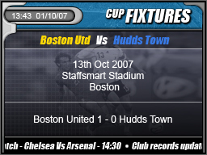

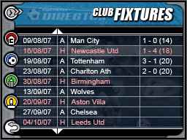

### Tactics

*Spawns: None*

This screen is very important as you will be setting your overall team strategy for your matches.

On the top screen the current formation (which is set on the Squad screens formation tab) is shown. On the bottom screen are several options which are used to set the team tactics.

Three of the options are represented with bars

1. **Style of Play:** You can decide that your team will focus on attacking, short ball, zonal, etc.
2. **Marking:** How will your team play defensively. You can choose a number of options.
3. **Aggression:** Adjust the slider bar to increase or decrease the aggression of your team. The more aggressive your players are the more determined they will be in the game, but it may mean more free kicks given away and more chance of players getting yellow and red cards. Use high aggression sparingly to avoid having too many players suspended at the same time.

***Play on the Break:***

Tick the box to play this tactic.  The team will mount quick counter-attacks from defensive positions, trying to catch out the opposition with a combination of speed and surprise.

***Offside Trap:***

Tick the box to play this tactic. Players will rush out of defense at the appropriate moment and try to catch the opposition's attackers off-side.

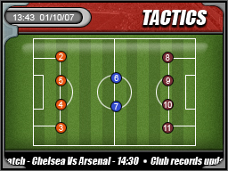

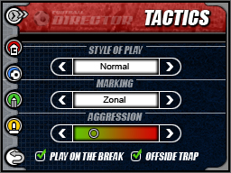

## League menu

### League fixtures

(partially mocked up using cup fixtures mock-up)

*Spawns: Links to opposition clubs and match reports*

On this screen it is possible to view every division’s fixtures for any match day of the season. If the matches have been played then the result is displayed and selecting a match will display a match report, likewise tapping a club name will bring up the specific information on that club. The boxes with the arrows either side allow changing of the date or division being viewed



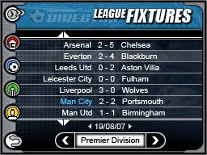

### Cup Fixtures

*Spawns: Links to opposition clubs and match reports*

This screen serves the same purpose as the league fixtures page for all the cup competitions allowing viewing of the fixtures. The selection boxes on this screen allow changing between different cups and rounds of that cup.



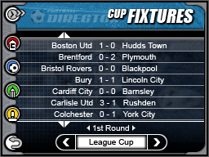

### League and Current Form Tables

(this screen not mocked up)

*Spawns: Links to other clubs*

The League Tables screen is where you can see stats and information for each team in every division.

On the top screen a summary of the current selected club is shown, on the bottom screen is the league table. To switch between the various sets of information for the league you can use the tabs below the table to switch between the following:-

* **League:** You can see the details for each team's overall league standing this season. This table is sorted as expected and shows the promotion and playoff spots.
* **Home:** You can see how the team has performed in it's home division matches this season.
* **Away:** See how each team did on the road in the league this season.
* **Form:** See how the teams have performed over the last 6 league games.
* **Discipline:** You can see how many yellow and red cards each team has picked up in the season to date.

You can select any team to see information on them and their first team squad on the top screen. When a team is selected a button will appear to view the clubs specific screen to allow more detailed inspection of the club.

### Leading Goal scorers/Disciplinary Tables

(this screen not mocked up)

*Spawns: Links to opposition clubs and players*

This screen appears as a table with tabs below and shows both the leading goal scorers in each division and the disciplinary record league based on the number of disciplinary points a player has (3pts for a yellow card, 6 points for a red card).

To switch between showing the goal scorer league and disciplinary league use the tabs below the table.

Selecting a player will show their information on the top screen and upon selection buttons will appear to perform operations on that player.

### Cup Schedules

(screen not mocked up – similar to fixture screens)

*Spawns: Links to opposition clubs and players*

This screen shows the dates each round is played, drawn and replayed for each of the cups (English, League, and Charity Shield).

The dates and descriptions for that date are shown in a scrollable list. Below this is a selection box to change between the cups schedule being shown.

## Admin menu

### Bank, Accounts

*Spawns: Nothing*

This screen lets the player view and control the financial situation of the club. On the top screen the current accounts breakdown is shown for the club listing the weekly and season to date income, expenditure, profit and loss. The player can’t influence all of these figures directly but success on the pitch will generate more income. You can view the current week or year by tapping on the appropriate tabs (shown on the bottom screen).

On the bottom screen there are the controls for the banking. These allow the player to borrow and repay money. Use the arrows to raise or lower the amount or tap inside the number range to set the amount you want. You can also see how much money you have, your outstanding loan, weekly payments and how long the loan will take to pay off.

The default value in the 'Apply to Borrow' box is the recommended amount that the bank will lend you, any higher than this is likely to be refused by the bank.

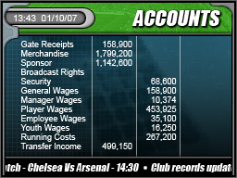

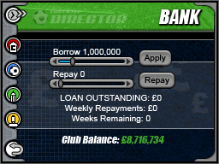

### Job Centre Screen

*Spawns: Employee info, Sack Employee, Employee negotiations*

This screen is used to look for and recruit new backroom staff. The bottom screen shows you the non-player employees that you currently have hired on the left and the ones that are available for hire on the right. By tapping on a name with the stylus a person is selected and their details shown on the top screen.

Upon selection buttons appear on the bottom screen to perform actions on the selected person. These actions are :-

* **Sack :** You can fire the employee.
* **Offer Contract :** You can extend an employee's contract. You can set their wage and contract terms. They may or may not accept your offer.
* **Hire :** You can offer a person a job. You can set their wage and contract terms. They may or may not accept your offer.

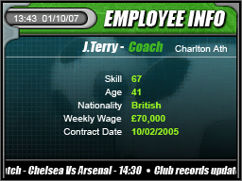

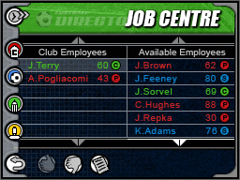

### Youth Squad

### **(No mock-up, similar to Job Centre)**

*Spawns: Youth info, Sack, Youth negotiations*

The Youth Squad is where the player can check out the up-and-coming talent in your organization and youth players available to buy. By tapping on a player the following action buttons appear:-

* **(if a current player) Sack :** Let the youngster go, removes him from your payroll
* **(if a current player) Promote to First Team :** Promote him to the first team. You can set their wage and contract terms. They may or may not accept your offer this is done on the youth negotiations screen.
* **(if not a current player) Hire :** Recruit a youth for your Youth Squad.

### Transfer List

*Spawns: Player Info, Player Loan negotiations, Player Transfer negotiations, Player Contract negotiations.*

In order for the player to improve their squad, sooner or later they are probably going to want to buy new players from the transfer market.

The bottom screen shows the list of players available having been filtered by the current filter. The filters can be easily switched between using the left and right arrows in the box in the bottom right. To create or edit a filter the player can press the ‘Edit Filter’ button which allows them to set the parameters of the filter.

To view more information on any player tap their name in the list and the information will appear on the top page.

In order to attempt to loan or buy a player, highlight their name by tapping on it and then select either **'Loan Player'** or **'Buy Player'**. This will take you to the relevant screen.

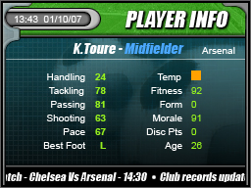

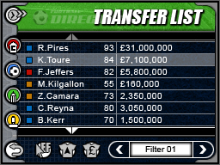

Edit filter page

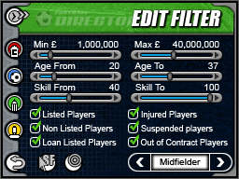

## General screens

### Match Intro

(screen not mocked up yet)

*Spawns: Inspect players, opponent detail screens.*

The Match intro screen allows you to do a number of things

* **Match :** View the match (play by play) and adjust your strategies or just check out the results.
* **Teams :** Check out the team line-ups.
* **Subs :** See what subs are available for the match.
* **Report :** Gives information about your opponent's strengths and weaknesses. N.B. This will not be available for the first few matches of the season, until information has been acquired from previous matches. This report is also sent to the player in their news updates before the match.

At the start of each match that the user’s team is to participate in a series of screens are displayed which allow the user to view information such as team line-ups, and a few hints as to what the opposition’s strengths and weaknesses are. On the main page is the completion name, the clubs involved with their league positions in brackets if it is a league match, and the stadium name, the user must select whether to view the match (commentary) or simply to skip to the end and read the report.

### Match screen

*Spawns: Player screens*

The match day screens are laid out slightly differently to the normal game screens.

The top screen shows the match time in the top left corner and the ticker becomes a commentary bar. The main part of the top screen shows goal scorers and disciplinary times.

The bottom screen top left corner changes to have a play / pause match button with a dial to change the match speed from slow to fast. The button in the bottom left skips the match, the top right button goes to the squad page to perform substitutions and tactical changes and the menu icons along the left switch between the various information screens for reviewing during the match (the current screen being highlighted).

The four screens accessible are

* **Commentary** – show minute by minute scrollable commentary of the match
* T**eam -** Allows you to view both squads, view details and fitness levels
* **Events -** Shows you how both squads are doing during game play on things like free kicks, shots off target, etc.
* **Skill -** Shows the possession of players within your team and as a whole what percentage of play your team is having.

*Top screen*

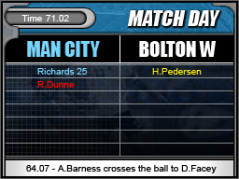

*Bottom screens*

Skill screen, note the highlighted icon

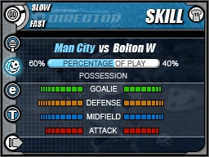

Team sheet screen

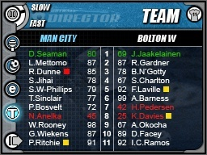

Commentary screen

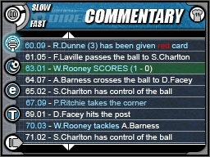

Events screen

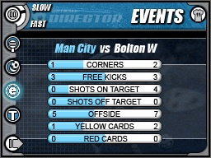

### Progress

(no mock-ups)

*Spawns: None*

This screen appears when the game is processing and shows news flashes and results when they are calculated.

### Incoming Transfer Offers

*Spawns: View player details further, view club details*

At any time during the game, the user might receive an offer by another club for one of your players. On this screen you can,

* **View Details -** Check out the stats, personal details of the player in question etc.
* **Accept -** Accept the bid as it has been offered.
* **Reject -** Reject the bid outright.
* **Counter -** Counter the offer and, perhaps, ask for more money.
* **Action -** Set the players transfer status, sack him or offer him a contract.

There are also two other areas on the screen:

* **Offer :** Use the arrows to adjust the offer.
* **Sell On Clause :** The percentage of the transfer fee to be received by the selling club when the buying club transfers the player to another club.

This mock-up shows the rough layout of the screen, upon changing the offer bars the accept button would change to ‘counter’. Buttons would be also available for the actions applicable to the player

The top screen would show the current effect of your counter / acceptance / rejection in a dialog box as shown when you make a decision, before then it shows the players information.

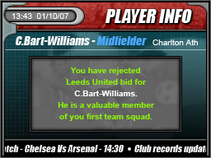

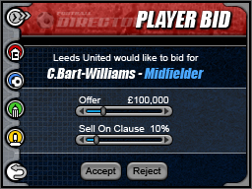

**Youth negotiations**

(player info mockup used for top screen)

*Spawns: View player details further*

This screen is for contract negotiation with a youth player and allows you to set how much per week you are willing to pay him and for how many seasons you wish him to play for your club, when you have entered these, tap on the 'offer' button and his response will appear in the bottom half of the screen.

Note the top mockup would show the progress of the negotiation with the player rather than the example shown

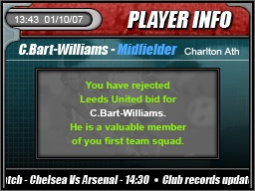

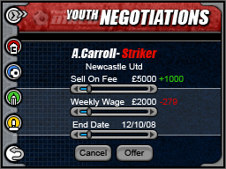

### Employee negotiations

*Spawns: View employee details further*

Similar to the youth negotiations, this screen is where you offer the employee a weekly wage, and how long you wish him to work for the club. The top screen again shows the information on the person in question and shows the current status of negotiations when an action is taken in the negotiation process.



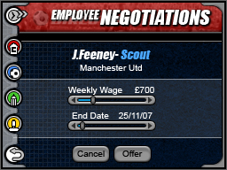

## General (spawned from clicking on an item or from a selection)

### Match Report

(mock-ups from cup fixtures screen and match screens)

*Spawns: Can access players, club information*

The match report screen shows the final result on the top screen and allows browsing of the final versions of all the sub-screens from the match (Skill, Events, Team, Commentary)

Note: this mock-up is what the top screen of a match screen would look like



Skill screen, note the highlighted icon

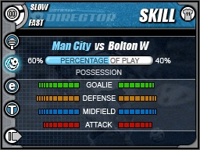

Team sheet screen

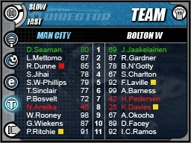

Commentary screen



Events screen



### Player Transfer Status

(no mock-ups)

*Spawns: View further player info.*

Through this screen the player can set an individual players transfer status. The screen is made up of checkboxes and a bar for setting the value to reject bids below. Check the boxes for the options you want to set:

* **Transfer List:** Signals to other clubs that you are willing to sell the player if a suitable offer is received.
* **Reject Bids Below:** You can automatically set the game up to reject any bids below a certain amount.
* **Reject All Bids:** This will keep other clubs from making offers to you for the player.
* **Available for Loan:** Informs other clubs that you would consider loaning the player for a specified number of weeks.

### Youth Profile

(no bottom screen mock-up and top screen represented with player info mock-up)

This screen displays all the information available on the youth player on the top and bottom screens. Along the bottom screen are the buttons ‘Promote’ and ‘Sack’. Tapping on the 'Promote' button takes you to the contract negotiation screen and clicking on the 'Sack' button removes the youth from the youth squad of your club.



### Employee Profile

(no bottom screen mock-up)

This screen displays all the information available on the employee, tapping on the 'Sack' button on the bottom screen allows you to make remove the employee from your club's payroll but you will have to pay him the full amount of his salary for the duration of his contract as a lump sum immediately.



### Player Profile

(no bottom screen mock-up)

Displays all the information available on the player, tapping on one of the buttons on the bottom screen allows you to make decisions regarding the players position within the club.

Although summaries of player info are shown on the top of other screens such as the squad screen, this screen will display further information on the bottom screen where available.

The actions possible include renewing the player’s contract or placing him on the transfer list if he owns the player or if he doesn’t then he can make a bid to either purchase or loan the player.



### Manager Profile

(no mock-up available)

Show the profile of a manager on the top / bottom, where they manage and has links to the club they manage and their last signing. There are no possible actions that can be used on the selected manager

### Player requests transfer

(no mock-up available)

This screen is used when a player requests a transfer away from the club as they are unhappy with his current role within the club; it is for you to decide whether you are prepared to grant his request, the choice you make will affect his attitude and morale.

The top screen will show the players summary info and the bottom will show details of the transfer request and actions on whether to accept or reject the transfer request.

### Player Contract Negotiations

(partial mock-up using youth negotiations screen)

This screen is used for negotiating contracts with new players and with existing players in the squad.  The player can offer the weekly wage, contract length and amount of signing on fee to the player.





### Player Loan Negotiations

This screen is used to bid to loan a player, the only option necessary is to decide how many weeks the user would like to loan him for. The players club will become responsible for their 100% of the player's wages whilst they are playing for you so it is a good idea to check how much the player is earning by visiting their **'Information'** screen before offering to loan them.

The screen will inform the player of their invalid request upon entering the screen if they already have already had more than 6 players on loan within the current season.

A status box will appear indicating whether the player has accepted or rejected your loan offer.



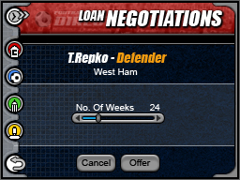

### Club Transfer Negotiations

*Spawns: Player info, club info when clicking on links to view further information*

This screen allows the user to bid to buy a player from another club and set the transfer fee and may also offer a sell on clause where a specified percentage of any future transfer is paid to his current club if he is sold again.

* **Transfer Fee:** This is the amount of money you are willing to pay the player's current club to release him from his contract.
* **Sell On Clause:** The percentage of the transfer fee to be received by the selling club when the buying club transfers the player to another club.

As with other negotiations screens the top screen shows the information on the person in question and also a pop up box with the current state of negotiations.



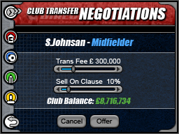

### Release Player

(no mock-up)

*Spawns: Nothing*

On this screen the player can release a player immediately, but will have to pay him the remainder of his contract value, if the board feels he is too valuable to lose they will override the player.

On the top screen the player info summary is shown and on the bottom the status of the sacking process is shown.

### Monthly Awards

(no mock-up)

*Spawns: Manager info, Club info*

This screen shows the Manager of the month awards for each of the four divisions every month of the current season. A selection box with arrows either side lets the player choose the month to view and the manager of all four divisions is shown and can be selected to view the manager or their clubs profile.

### Team of the week

(no mock-up)

*Spawns: Player info, club info*

This screen displays the best performing player in each position of all clubs in the currently selected division during the last match. The division may be changed by selecting another one from the list box at the bottom of the screen.

Perhaps show the formation on the top screen and their names + clubs on the bottom and highlight the top screen when a player on bottom selected.

# Control System

The game is controlled with the ***stylus*** for the majority of screens, also the previous screen be returned to with either the back button in the corner of the screen or pressing the ‘B’ button.

# Help System

The game features a help system with context sensitive help within each screen and for each statistic in the game. When the help function is enabled (either set to enabled when creating a new game) or from the options menu a button with ‘?’ on it will appear in the corner of the screen. Pressing this will fade down the current screen and give the player information on the current screen and the information presented on it.

# Music and SFX

The game will feature several music tracks to provide variation for the player. Sound FX use in the UI will be handled to prevent annoyance through repetitive sounds as the UI is so heavily used in the game. During the match screen the player will hear the crowd cheer and boo accordingly with the flow of the game and will hear the referee whistle for a stoppage in play.

# Milestones

**Note: Milestone definitions may be adjusted with each delivery to reflect slight alterations pre-Beta.**

|  |  |  |
| --- | --- | --- |
| 20/11/07 | M0 | Signature |
| 28/11/07 | M1 | DDP delivery |
| 11/12/07 | M2 | *Development as schedule in DDP*   * *Initial UI implemented with placeholder artwork.* * *UI is a shell allowing viewing of a selection of the screens enabling testing of some UI elements.* * *No actual gameplay or save data* |
| 15/01/08 | M3 | *Development as schedule in DDP*   * All UI screens implemented with placeholder graphics and linked up according to flow * Game partially integrated with UI * Game creation possible * Viewing squads, players and dummy match reports |
| 29/01/08 | M4 | *Alpha*   * Game saving to EEPROM * Interface and game complete with placeholder graphics and bugs |
| 18/02/08 | M5 | *Beta*   * No major bugs, game complete * Interface and game tweaked |
| 10/03/08 | M6 | *Master submission*   * *Lot check compliant* * *Final data integrated* |
| 28/04/08 | M7 | Master approval |